**23CSE111**

**OBJECT ORIENTED PROGRAMMING**

**LAB REPORT**



**Department of Computer Science Engineering**

**Amrita School of Computing**

**Amrita Vishwa Vidyapeetham, Amaravati Campus**

**Name:M.SAI MOKSHITHA**

**Verified By Roll No: 24151**

**WEEK 01**

**PROGRAM-1:**

**AIM:** Download and Install Java Software

**PROCEDURE:**

**Step 1: Download JDK 21**

1. Open your web browser and go to the Oracle JDK Downloads page
2. Scroll down to the Java SE Development Kit 21 section.
3. Choose the Windows x64 Installer version.
4. Click on Download, then Wait for the download to complete**.**

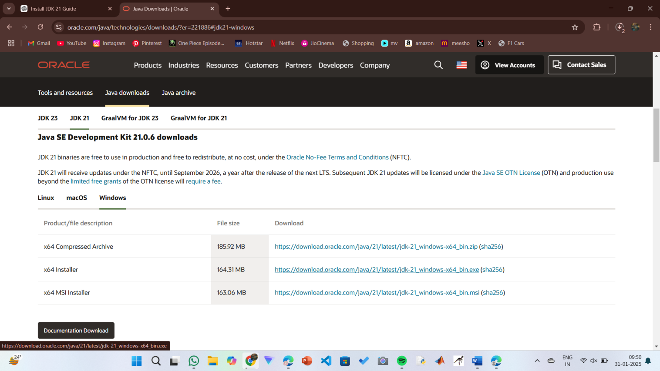

**Step 2:** **Install JDK 21**

1. Locate the downloaded jdk-21_windows-x64_bin.exe file.
2. Double-click to launch the installer.
3. Click Next on the setup wizard.
4. Choose the installation path (default is C:\Program Files\Java\jdk-21).
5. Click Next, then click Install.
6. Wait for the installation to complete.
7. Click Close once the installation is finished.

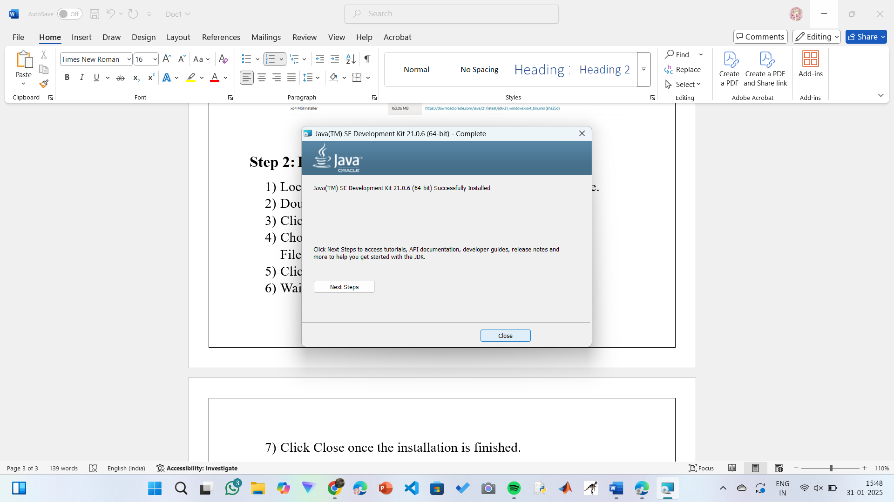

**Step 3: Setting up the path**

1) Go to “Windows C” Drive on Desktop

2) Choose Program Files, select Java, then JDK 21, then select Bin.

3) Select and copy the path at the address bar.

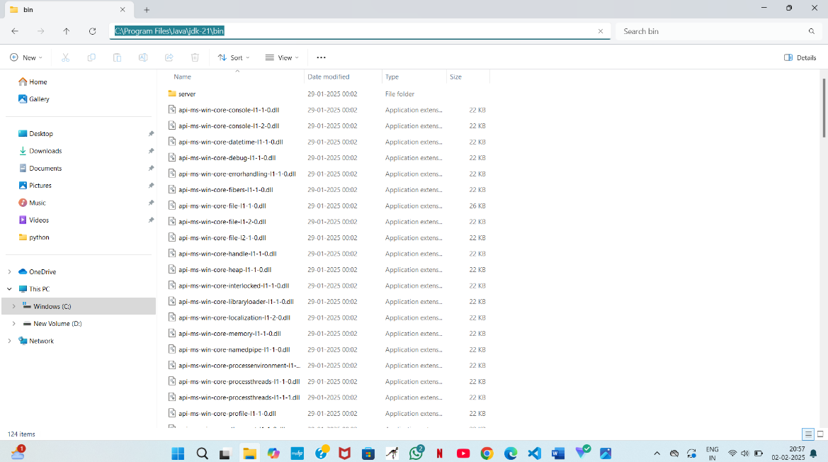

**Step 4: Open System Properties**

1. Press Windows + R, type sysdm.cpl , and click Ok-
2. The System Properties window will open.
3. Navigate to the Advanced tab.
4. Click on Environment Variables at the bottom.

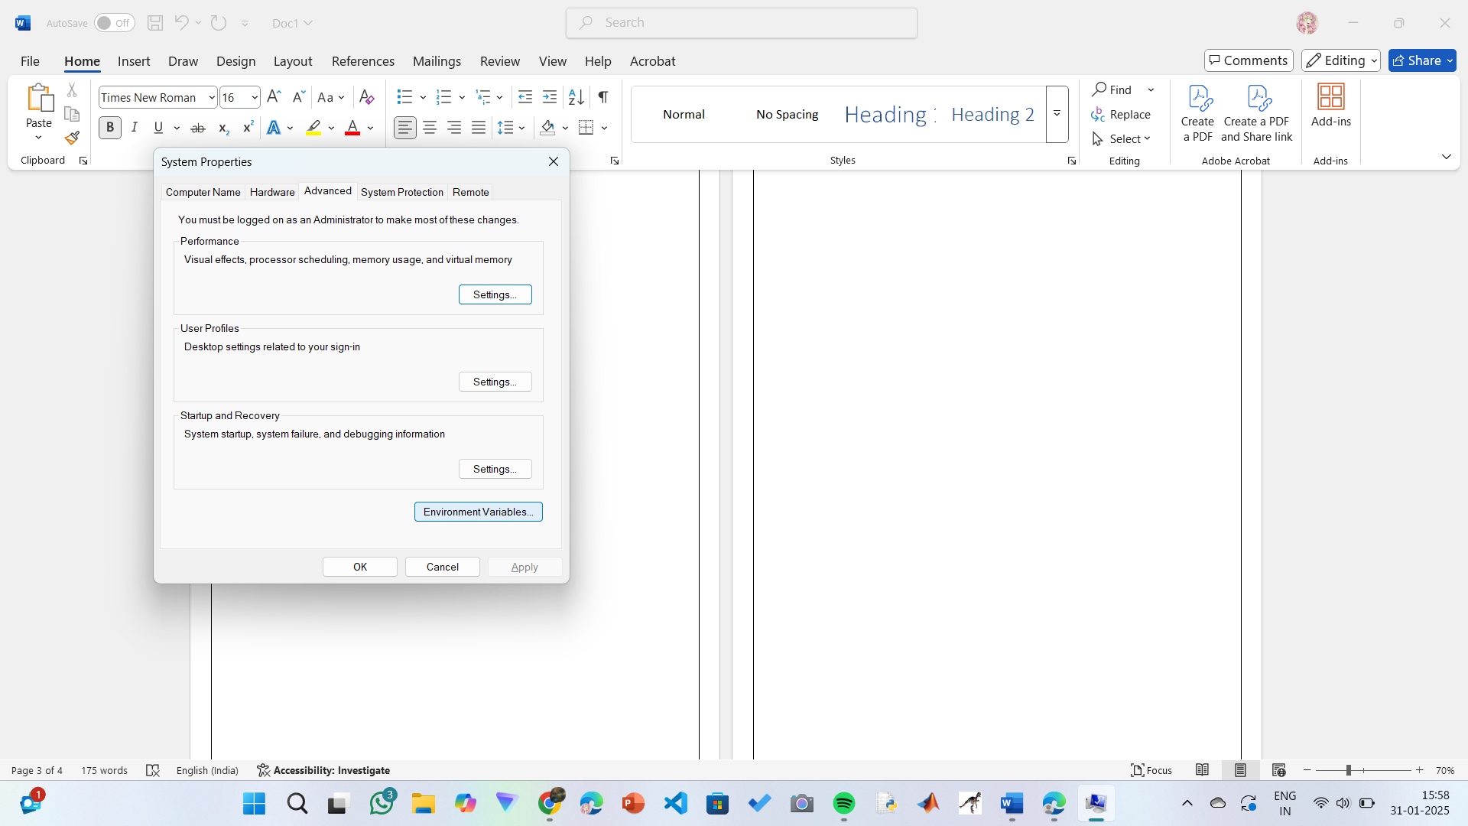

**Step 5: Set JAVA_HOME**

1)Under System Variables, click New.

2)Set the Variable name as JAVA_HOME.

3)Set Variable value as C:\Program Files\Java\jdk-21 (or your installation path).

4)Click OK.

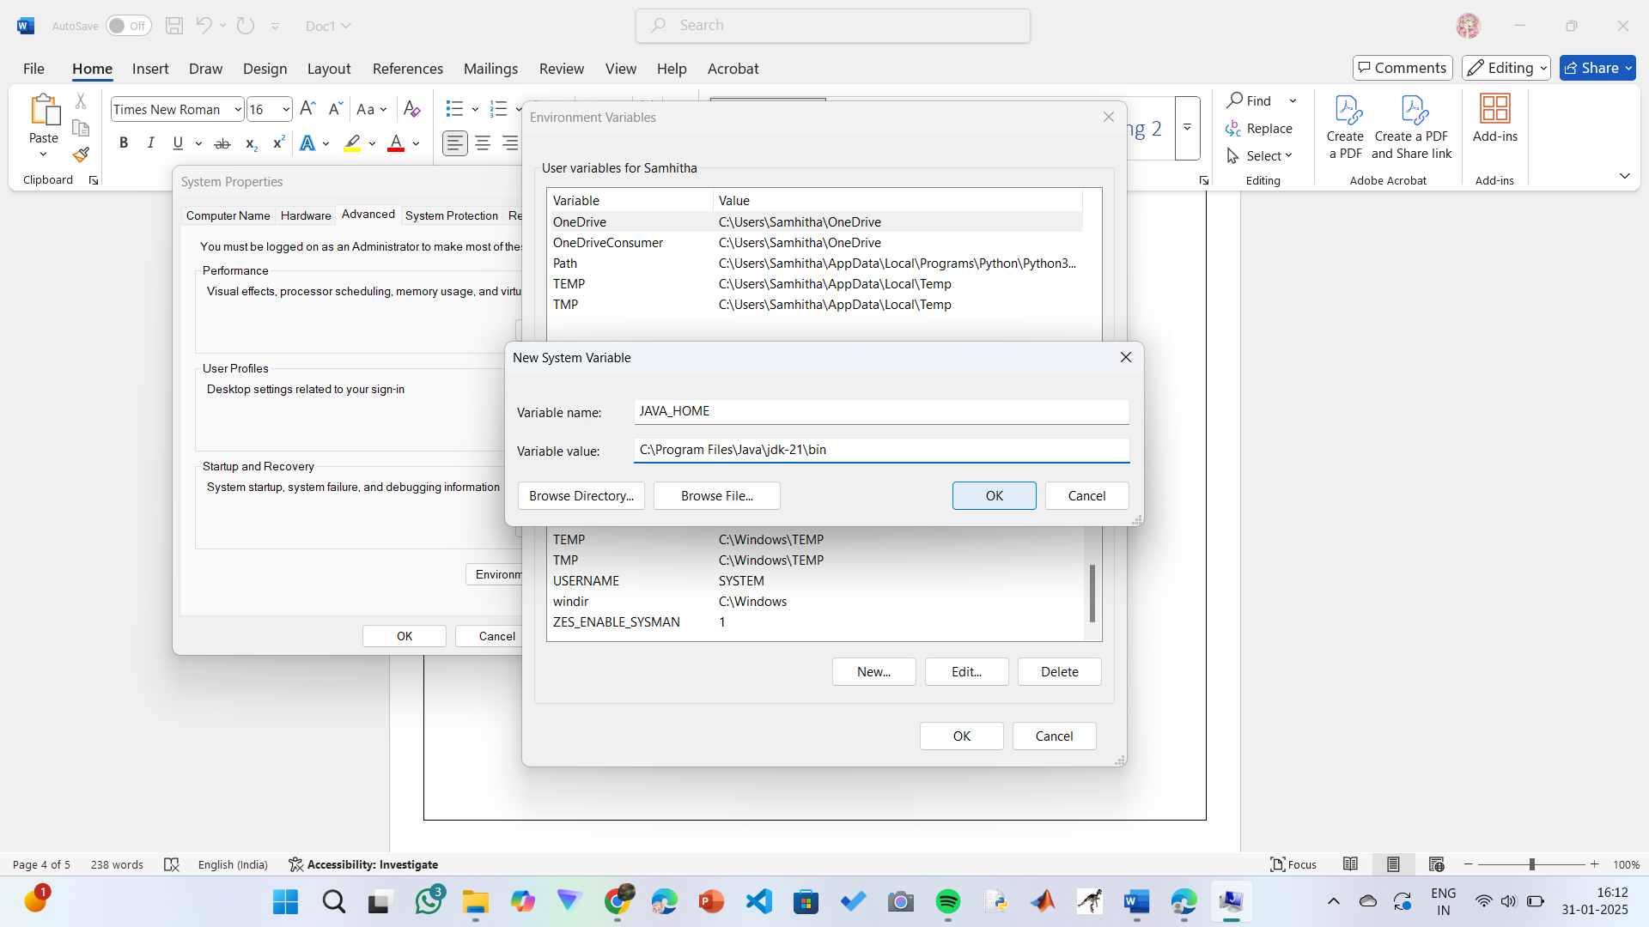

**Step 6: Update PATH Variable**

1)In System Variables, find Path and click Edit.

2)Click New and add: C:\Program Files\Java\jdk-21\bin

3)Click OK to save.

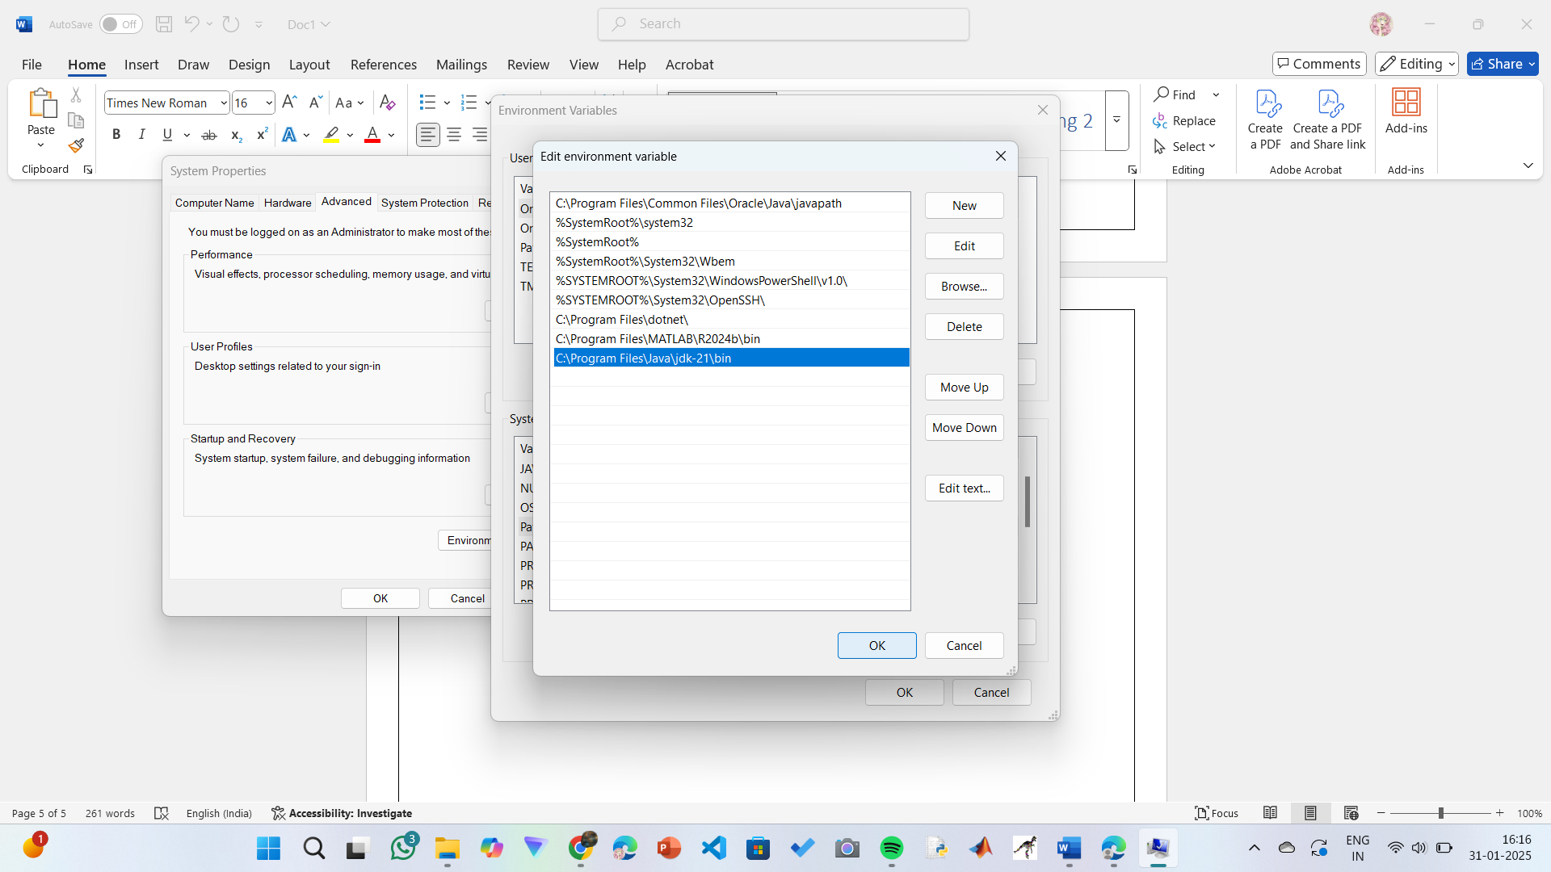

**Step 7:Verify Installation**

1. Open Command Prompt.
2. Type the following command: **java --version** and press Enter.

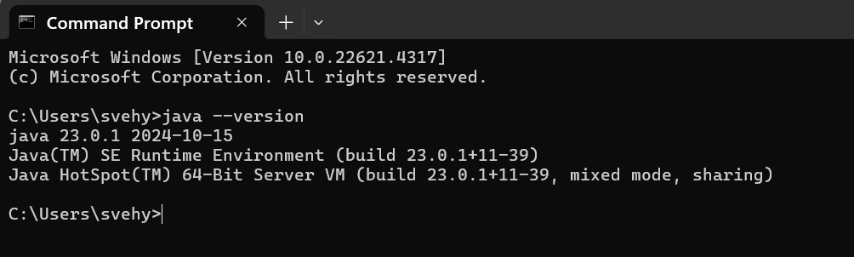

1. To check the java compiler type: **javac –version.**

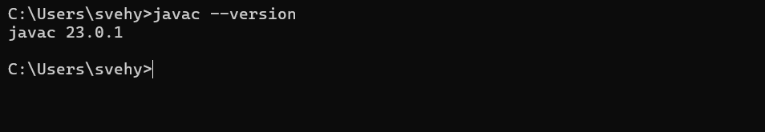

**PROGRAM-2:**

**AIM:** Write a Java program to print the message “Welcome to Java Programming.”

**CODE:**

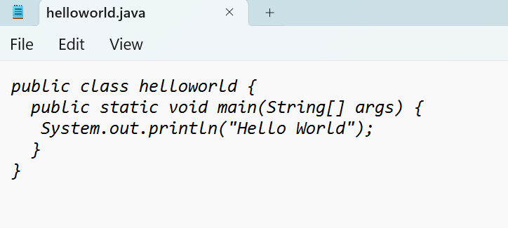

**Output:**

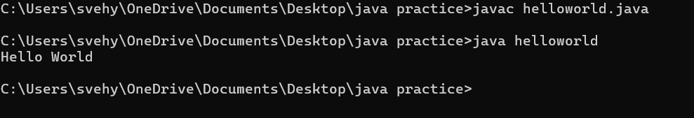

**ERRORS:** None found

**PROGRAM-3:**

**AIM:** Write a Java Program that prints Name, Roll No, Section of a student.

**CODE:**

**STUDENT DETAILS:**

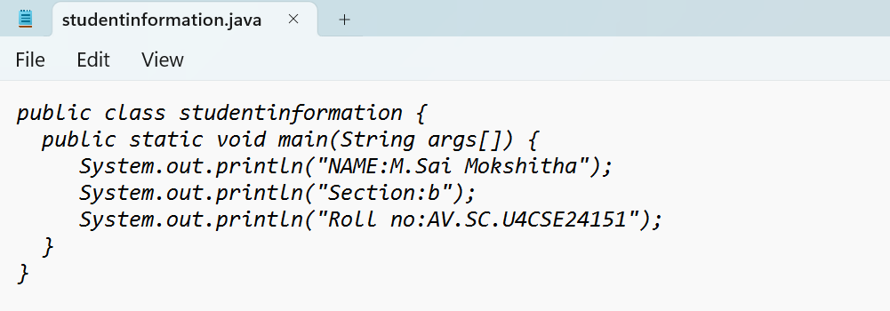

**OUTPUT:**

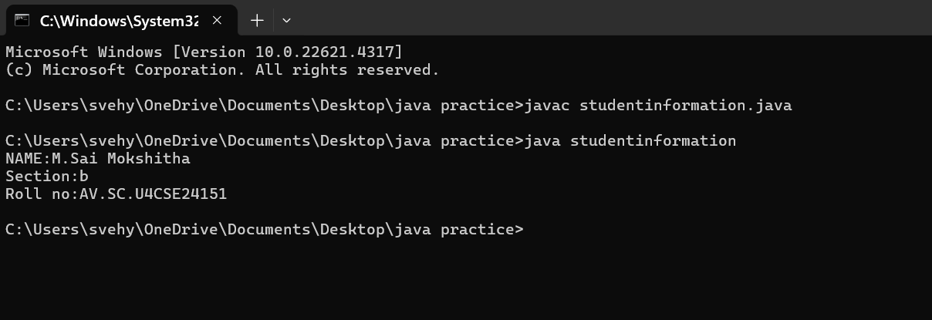

ERROR TABLE:

|  |  |
| --- | --- |
| **Code Error** | **Code rectification** |
| 1. writing small “S”in place of”S”   In system.out.println()  2)not giving strings to the name and section | 1. code is rectified by keeping capital “S” 2. Giving strings to name and section |

**PROGRAM-4:**

**AIM:** Calculate area of rectangle.

**CODE:**

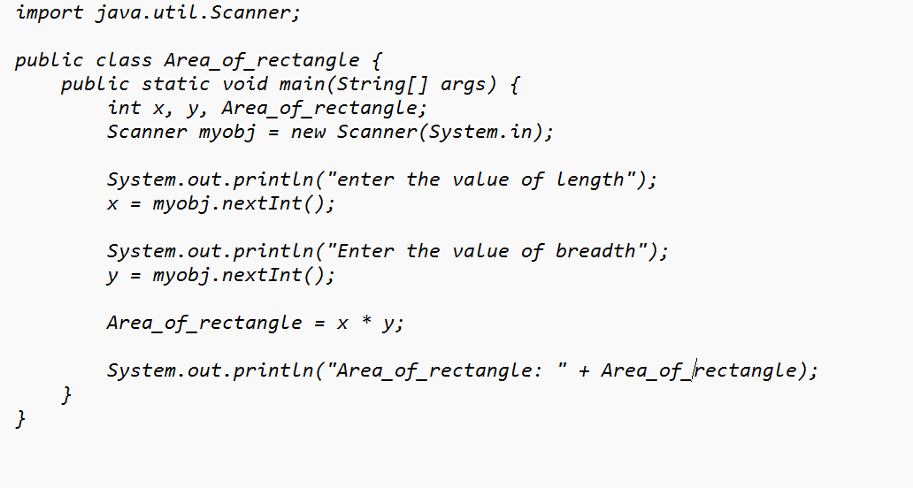

**OUTPUT:**

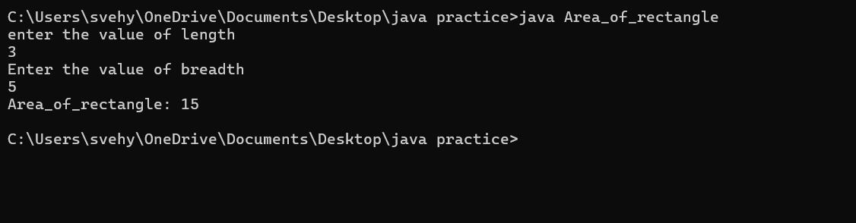

ERROR TABLE:

|  |  |
| --- | --- |
| **Code Error** | **Code rectification** |
| 1. While using for iteration, not giving the conditions correctly. 2. Declaring the data type as double instead of int. | 1. We should give iterative statements correctly. 2. We should give the data type as int for integers. |

IMPORTANT POINTS:

1. Area of a rectangle is area = l*b, where

L = length of a side of the rectangle,

B= breadth of a side of the rectangle.

1. Here, we must be sure that all the expressions/conditions inside for

the for loop must be given correctly.

**PROGRAM-6:**

**AIM:**Calculate the simple interest

**CODE:**

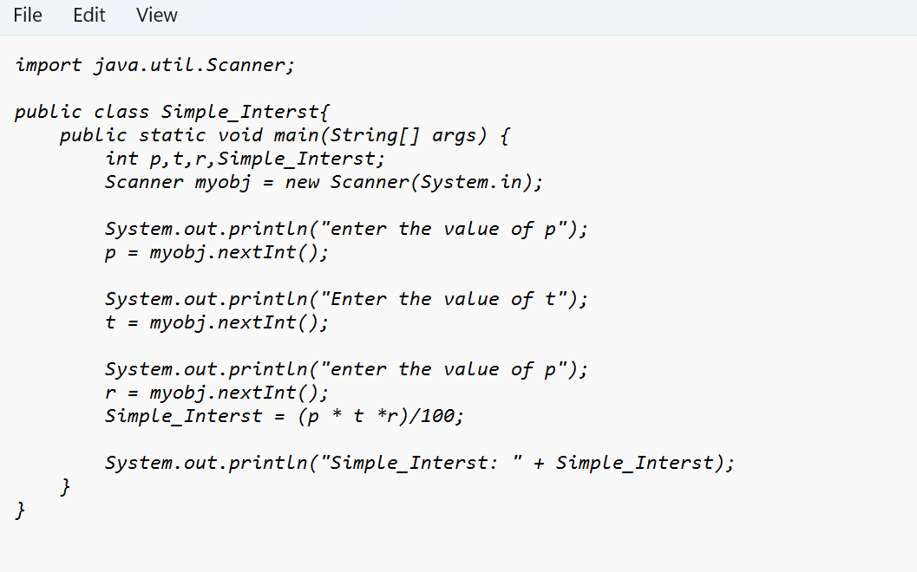

**OUTPUT:**

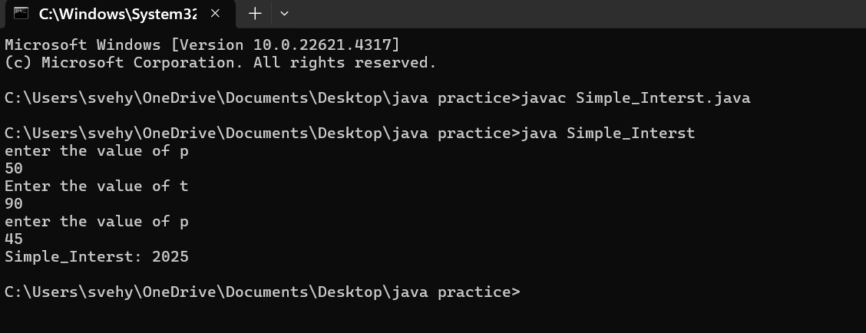

ERROR TABLE:

|  |  |
| --- | --- |
| **Code Error** | **Code rectification** |
| 1. writing small “S” in place of ”S”   In system.out.println()  2)not giving strings to the name and section | 1. code is rectified by keeping capital “S” 2. Giving strings to name and section |

IMPORTANT POINTS:

1. Simple interest formula is: (p*t*r)/100, where:

P: Principal amount

R: Rate of interest

T: Time period

1. The data type double indicates the floating points in the integers.
2. The line “import java.util.Scanner” indicates:

Import: tells the java compiler that we want to use a specific class or package in your code.

Java.util : This is the package that contains utility classes for Java programming, including the “Scanner” class.

Scanner: this is the class that allows you to read input from the keyboard.

**PROGRAM-5:**

**AIM:**Convert temperature celsius into fahrenheit

**CODE:**

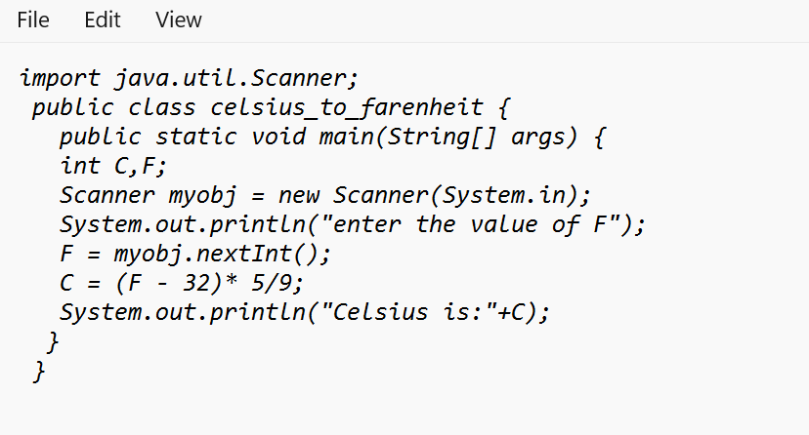

**OUTPUT:**

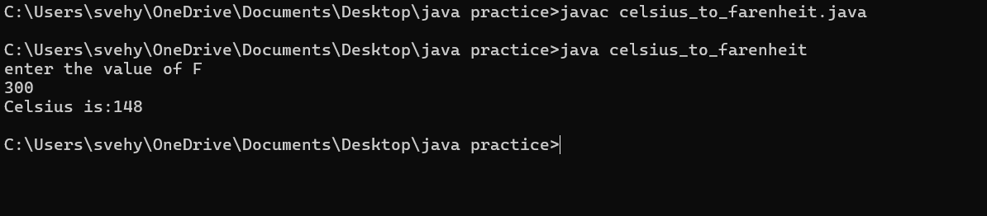

ERROR TABLE:

|  |  |
| --- | --- |
| **Code Error** | **Code rectification** |
| 1. While printing the variable not giving + sign. 2. Not closing the scanner. | 1. We should give correct indentation. 2. Closing the scanner is must. |

IMPORTANT POINTS:

1. The formula to convert a Fahrenheit to Celsius is

Celsius = (Fahrenheit-32)*5/9

1. The formula to convert a Celsius to Fahrenheit is

Fahrenheit = (Celsius*9/5)+32.

1. The line “Scanner input = new Scanner(System.in),” tends to create a new Scanner object named “input” that reads input from the standard input stream (System.in), like keyboard.

**PROGRAM-8:**

**AIM:**Largest of 3 numbers by ternary operators

**CODE:**

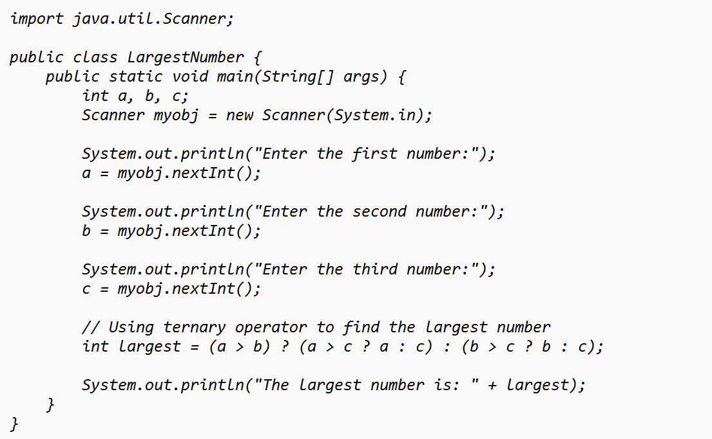

**OUTPUT:**

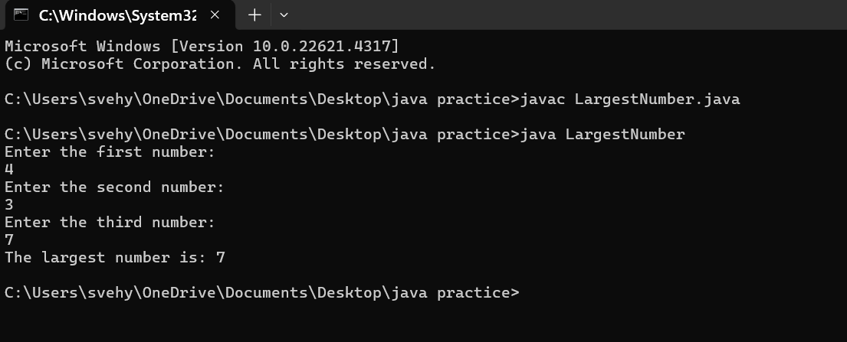

ERROR TABLE:

|  |  |
| --- | --- |
| **Code Error** | **Code rectification** |
| 1. writing small “S” in place of ”S”   In system.out.println()  2)not giving strings to the name and section | 1. code is rectified by keeping capital “S” 2. Giving strings to name and section |

WEEK – 3:

PROGRAM- 1:

AIM: To create a class BankAccount with methods deposit() and withdraw() . create two subclasses savingsaccount and checkingaccount override the withdraw () method in each subclass to impose different withdrawal limits and fees.

CODE:

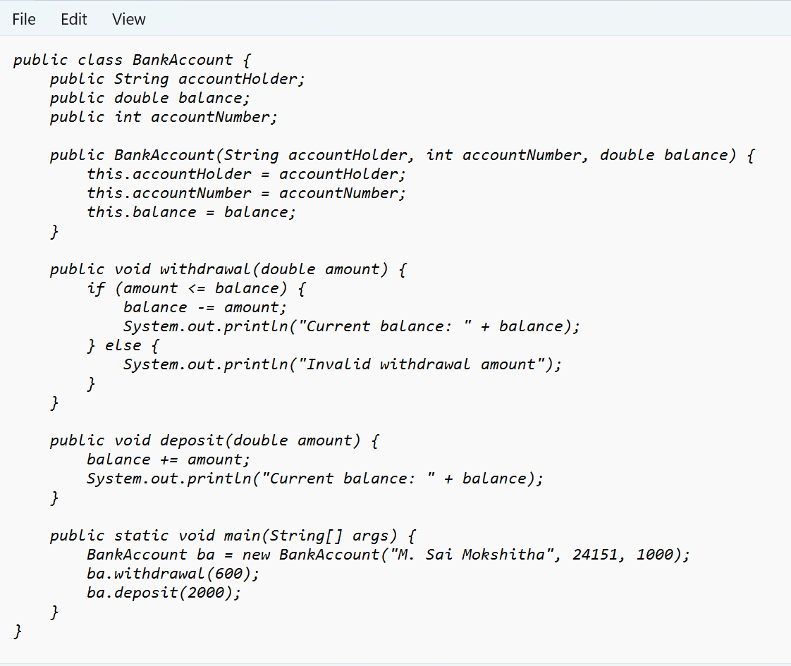

Output:

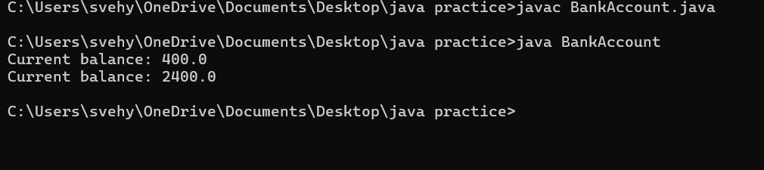

ERROR TABLE:

|  |  |
| --- | --- |
| **Code Error** | **Code rectification** |
| 1. Not putting the semi-colon; after calling the function. 2. After Withdrawal,deposit not giving the parenthesis ( ). | 1. Put the semi-colon after the writing the code. 2. After every method, put the parenthesis ( ). |

IMPORTANT POINTS:

1. The condition inside the if statement must be correct.
2. It explains that if the withdrawal money is less than the money in the bank account, then we can withdraw the amount.

**Class diagram:**

|  |
| --- |
| **BankAccount**  **----------------------------------------------------------**  **-balance: double**  **----------------------------------------------------------**  **+BankAccount(intialBalance: double)**  **+deposit(amount: double):void**  **+withdraw(amount: double):void** |

PROGRAM- 2:

AIM: To create java program with following instructions :

1. Create a class with name Car

2. Create four attributes named car_color, car_brand, fuel_type, mileage

3. Create these methods named start(),stop(),service()

4. Create the objects named car, car1,car2.

CODE:

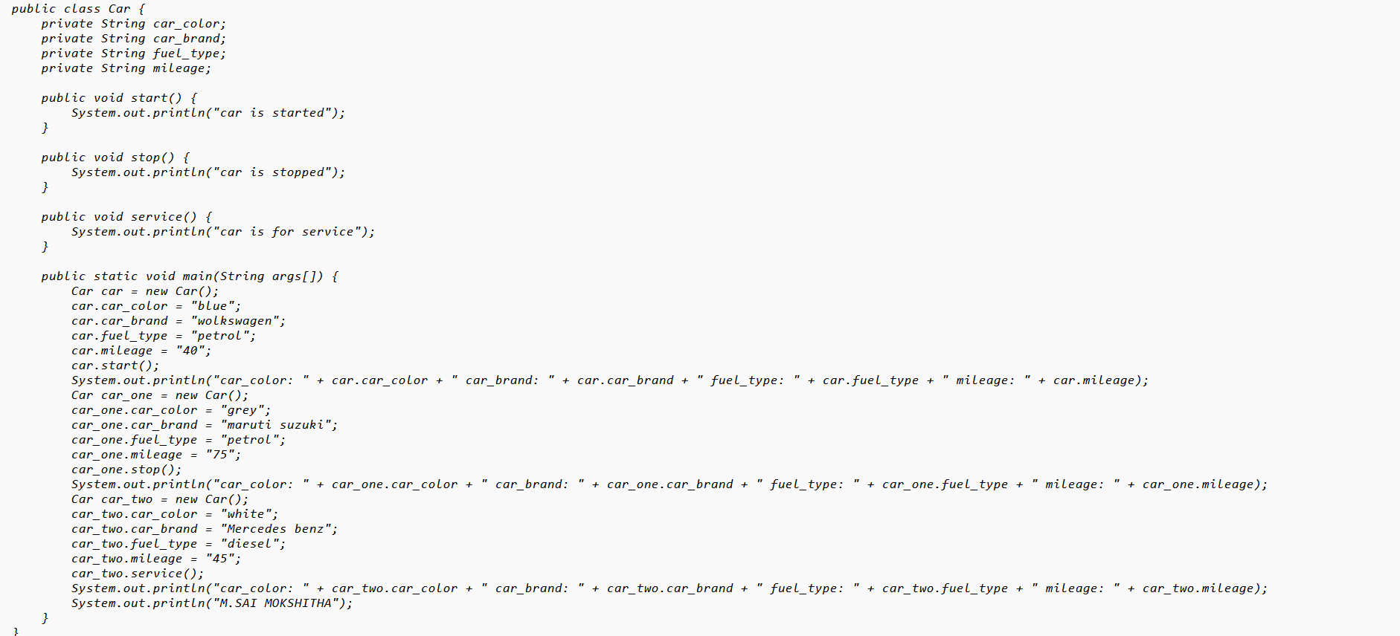

Output:

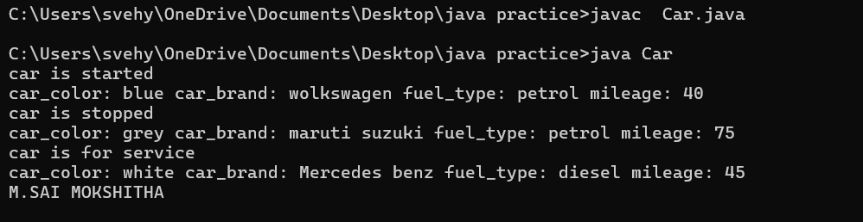

ERROR TABLE:

|  |  |
| --- | --- |
| **Code Error** | **Code rectification** |
| 1. Not putting the semi-colon; after calling the function. 2. After Start, Stop, Service not giving the parenthesis ( ). | 1. Put the semi-colon after the writing the code. 2. After every method, put the parenthesis ( ). |

IMPORTANT POINTS:

1. Before calling the function we should write the method properly.
2. Here, the “public void start( )” indicates that we are writing a method to call the function.
3. When we call a certain method, the process inside it will be printed as an output of the code.
4. Here the details inside the function are called objects, we can give any objects

**Class diagram:**

|  |
| --- |
| **car**  **-----------------------**  **-car_color:string**  **-car_brand:string**  **-fuel_type:string**  **-milage:double**  **----------------------**  **+start():void**  **+stop():void**  **+service():void** |